Assignment 13
DHCP Configuration

Shreya Panchal

Theory

What is DHCP?
DHCP (Dynamic Host Configuration Protocol) is a network protocol that automatically assigns IP addresses and other network settings such as Subnet Mask, Default Gateway, and DNS Server to client devices. It reduces manual configuration and prevents IP conflicts.

DHCP Process (DORA)
Discover – The client broadcasts a request to find a DHCP server.
Offer – The DHCP server offers an available IP address.
Request – The client requests the offered IP address.
Acknowledge – The DHCP server confirms the IP assignment.

Practical

Objective
Configure a DHCP Server in Cisco Packet Tracer and verify that client PCs receive IP addresses automatically.

Devices Used
- 1 Router
- 1 Switch
- 1 DHCP Server
- 2 Client PCs

Steps
- Open Cisco Packet Tracer.
- Place one Router, one Switch, one Server, and two PCs.
- Connect all devices using a Copper Straight-Through cable.
- Assign a static IP to the DHCP Server, as shown below.

Parameter | Value
IP Address | 192.168.1.2
Subnet Mask | 255.255.255.0
Gateway | 192.168.1.1

- Enable the DHCP Service on the server.
- Create a DHCP Pool with the following configuration.

Parameter | Value
Pool Name | LAN
Default Gateway | 192.168.1.1
DNS Server | 8.8.8.8
Start IP | 192.168.1.100
Subnet Mask | 255.255.255.0
Maximum Users | 50

- Set both PCs to obtain an IP address automatically.
- Verify that each PC receives a different IP address.

Result
Both PCs successfully received different IP addresses from the DHCP server, and network connectivity was verified successfully.

Task 1

Configure one DHCP server and two client PCs.
Answer: A DHCP server was configured in Cisco Packet Tracer with IP address 192.168.1.2. Two client PCs were set to obtain IP addresses automatically. The DHCP server assigned different IP addresses to both clients successfully.

Task 2

Draw the DHCP Process (DORA)
Step | Message | Direction
1 | Discover | Client → DHCP Server
2 | Offer | DHCP Server → Client
3 | Request | Client → DHCP Server
4 | Acknowledge | DHCP Server → Client

Explanation
- Discover: Client searches for a DHCP server.
- Offer: Server offers an available IP address.
- Request: Client requests the offered IP address.
- Acknowledge: Server confirms the IP assignment.

Task 3

Only one IP available in DHCP Pool

Configuration
Parameter | Value
Start IP | 192.168.1.100
Maximum Users | 1

Observation
Client | Result
PC1 | Received IP address 192.168.1.100
PC2 | Did not receive any IP address

Explanation
Only one IP address was available in the DHCP pool. Therefore, the first client received the IP address, while the second client could not obtain one because no additional addresses were available.

Task 4

Zomato Restaurant Wi-Fi Scenario

Devices
- DHCP Server
- Wireless Router
- Laptop
- Smartphone

Assigned IP Addresses
Device | IP Address
Laptop | 192.168.1.100
Smartphone | 192.168.1.101

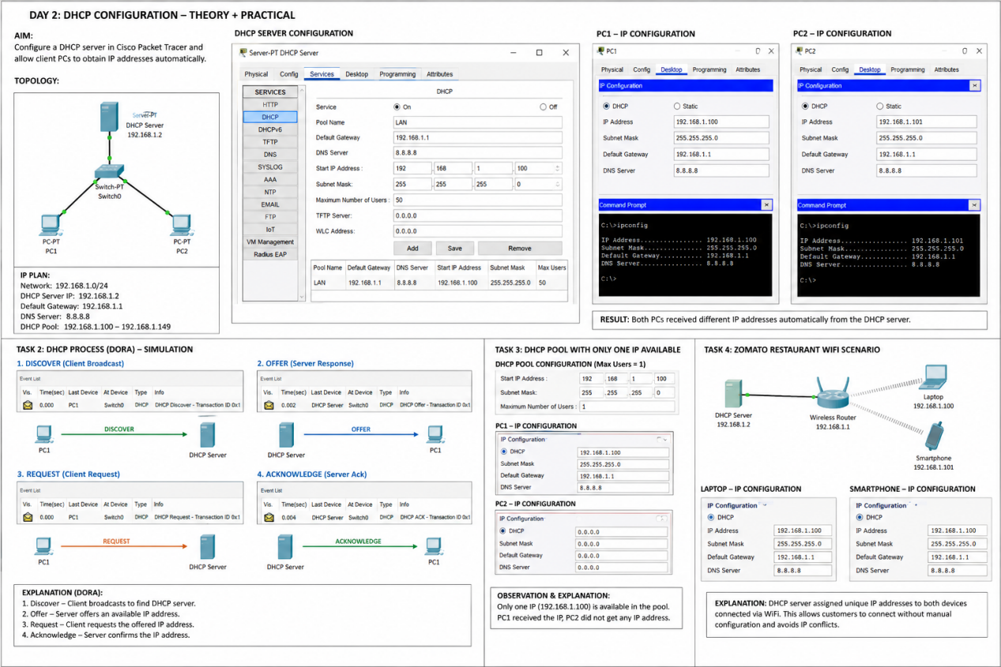

Explanation
DHCP automatically assigned unique IP addresses to both devices. This allows customers to connect quickly without manual configuration and avoids IP address conflicts.

Conclusion
DHCP simplifies network administration by automatically assigning IP addresses to devices. It saves time, reduces configuration errors, and prevents IP conflicts, making it an essential service in modern networks.

